Parking lot USB exercise

Review the following scenario. Then complete the step-by-step instructions.
You are part of the security team at Rhetorical Hospital and arrive to work one morning. On the ground of the parking lot, you find a USB stick with the hospital's logo printed on it. There’s no one else around who might have dropped it, so you decide to pick it up out of curiosity.
You bring the USB drive back to your office where the team has virtualization software installed on a workstation. Virtualization software can be used for this very purpose because it’s one of the only ways to safely investigate an unfamiliar USB stick. The software works by running a simulated instance of the computer on the same workstation. This simulation isn’t connected to other files or networks, so the USB drive can’t affect other systems if it happens to be infected with malicious software.
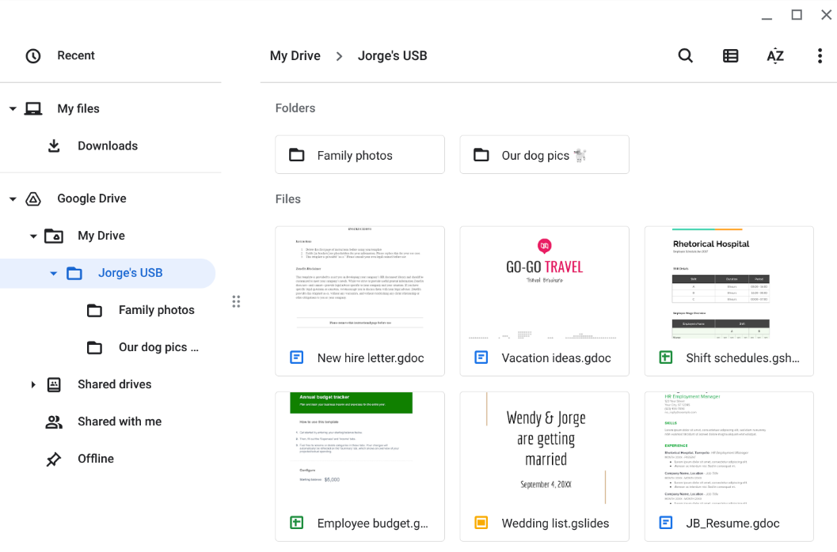
Jorge's drive contains a mix of personal and work-related files. For example, it contains folders that appear to store family and pet photos. There is also a new hire letter and an employee shift schedule.
Review the types of information that Jorge has stored on this device. Then, in the Contents row of the activity template, write 2-3 sentences (40-60 words) about the type of information that's stored on the USB drive.
The flash drive appears to contain a mixture of personal and work-related files. Consider how an attacker might use this information if they obtained it. Also, consider whether this whole event was staged.
For example, an attacker could have placed these files on the USB drive as a distraction. They might have targeted Jorge or someone he knows, hoping they would find the device and plug it into their workstation. In doing so, the attacker could establish a backdoor into the company's systems while the unsuspecting target browsed through the files.
In the Attacker mindset row of the activity template, write 2-3 sentences (40-60 words) about how this information could be used against Jorge or the hospital.
You have not opened any of the files on the device, which is best practice.
Attackers sometimes conduct USB baiting attacks to deliver malicious code that they've crafted.
However, this USB drive was still a security risk even though it did not contain malicious code. It could have easily been found by an attacker who might have used its contents to plan a variety of attacks.
Consider some of the risks associated with USB baiting attacks:
- What types of malicious software could be hidden on these devices? What could have happened if the device were infected and discovered by another employee?
- What sensitive information could a threat actor find on a device like this?
- How might that information be used against an individual or an organization?
In the Risk analysis row of the activity template, write 3 or 4 sentences (60-80 words) describing any technical, operational, or managerial controls that could mitigate USB baiting attacks.

Contents | Write 2-3 sentences about the types of information found on this device.  Some documents appear to contain personal information that Jorge wouldn’t want to be made public. The work files include the PII of other people. Also, the work files contain information about the hospital’s operations.
Attacker mindset | Write 2-3 sentences about how this information could be used against Jorge or the hospital.  The timesheets can provide an attacker intel about other people that Jorge works with. Either work or personal information could be used to trick Jorge. For example, a malicious email can be designed to look as though it comes from a coworker or relative.
Risk analysis | Write 3 or 4 sentences describing technical, operational, or managerial controls that could mitigate these types of attacks:  Promoting employee awareness about these types of attacks and what to do when a suspicious USB drive is a managerial control that can reduce the risk of a negative incident. Setting up routine antivirus scans is an operational control that can be implemented. Another line of defense could be a technical control, like disabling AutoPlay on company PCs that will prevent a computer from automatically executing malicious code when a USB drive is plugged in.

